**Setting Up a Host-Like Environment Using Docker Containers**

This documentation provides a step-by-step guide to create a Docker container that mimics a traditional host environment. The container will be capable of running multiple processes and services using supervisord as the process manager.

**Features**

* Nginx: Web server.
* MySQL: Database server.
* 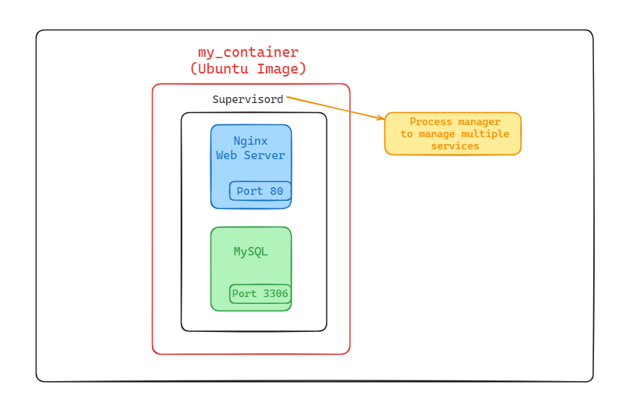Supervisord: Process manager to manage multiple services.

**Host-Like Environment Setup**

**1. Create Dockerfile**

**Create a Dockerfile with the following content:**

**[ Docker file code here, include ase ai folder ]**

**Explanation:**

* **Base Image:** ubuntu:latest provides a minimal Ubuntu environment.
* **Environment Variables:** DEBIAN_FRONTEND=noninteractive ensures package installations don't prompt for user input.
* **Package Installation:** Installs nginx, mysql-server, and supervisor, followed by cleanup to reduce image size.
* **Configuration:** Copies a custom supervisord configuration file into the container.
* **Ports:** Exposes necessary ports for Nginx and MySQL.
* **Entrypoint:** Uses supervisord to manage services within the container.

**2. Create supervisord Configuration**

**Create a supervisord.conf file with the following content:**

[supervisord]

nodaemon=true

[program:nginx]

command=/usr/sbin/nginx -g "daemon off;"

autorestart=true

[program:mysql]

command=/usr/sbin/mysqld

autorestart=true

**Explanation:**

* **supervisord:** Runs in the foreground (nodaemon=true).
* **Nginx:** Configured to run in the foreground (daemon off;) and restart automatically if it fails.
* **MySQL:** Configured to restart automatically if it fails.

**3. Build the Docker Image**

**Build the Docker image using the Dockerfile and supervisord configuration:**

docker build -t my_host_like_env .

**4. Run the Docker Container**

**Run the Docker container based on the image you just built:**

docker run -d --name my_container -p 80:80 -p 3306:3306 my_host_like_env

**Check the container is running using:**

docker ps

**The output will look something similar like this:**

CONTAINER ID IMAGE COMMAND CREATED STATUS PORTS

NAMES

30af6e1bfab8 my_host_like_env "/usr/bin/supervisord" 9 seconds ago Up 6 seconds 0.0.0.0:80->80/tcp, :::80->80/tcp, 0.0.0.0:3306->3306/tcp, :

::3306->3306/tcp my_container

docker exec -it my_container /bin/bash

**This will open a new terminal inside the container. You can now verify that Nginx and MySQL process running using:**

ps -ef

The ps -ef command is commonly used for system monitoring and troubleshooting to check which processes are running, their resource usage, and the commands used to start them.

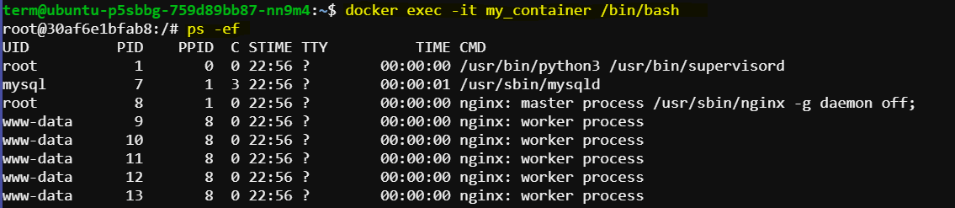

Exit the container using exit command.

**5. Access Services**

**Accessing Nginx Web Server**

**Access Nginx via curl or wget:**

curl http://localhost:80

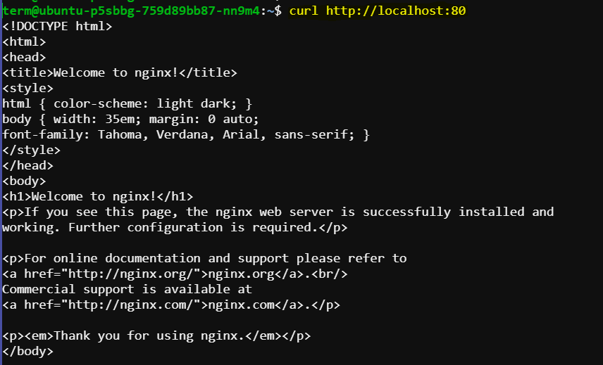If Nginx is running correctly, this command will fetch the default Nginx welcome page.

**Access Nginx logs:**

docker exec -it my_container tail -f /var/log/nginx/access.log

This command will show the Nginx access log. You can replace access.log with error.log for error logs.

**Accessing MySQL Database Server:**

**Access MySQL via MySQL Client:**

**Connect to MySQL server running inside the container**

docker exec -it my_container mysql -uroot -p

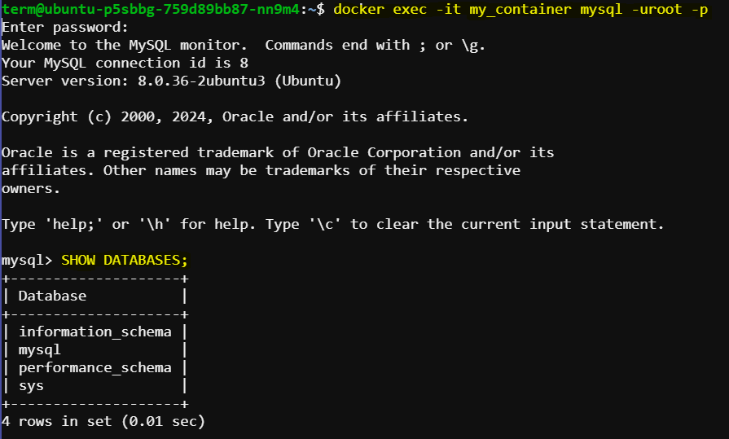If prompted for a password, the default password is empty (just press Enter). Once connected, you can interact with MySQL as you would on a standard MySQL server.

**Access MySQL logs:**

docker exec -it my_container tail -f /var/log/mysql/error.log

This command will show the MySQL error log. Replace error.log with query.log for the query log, if configured.

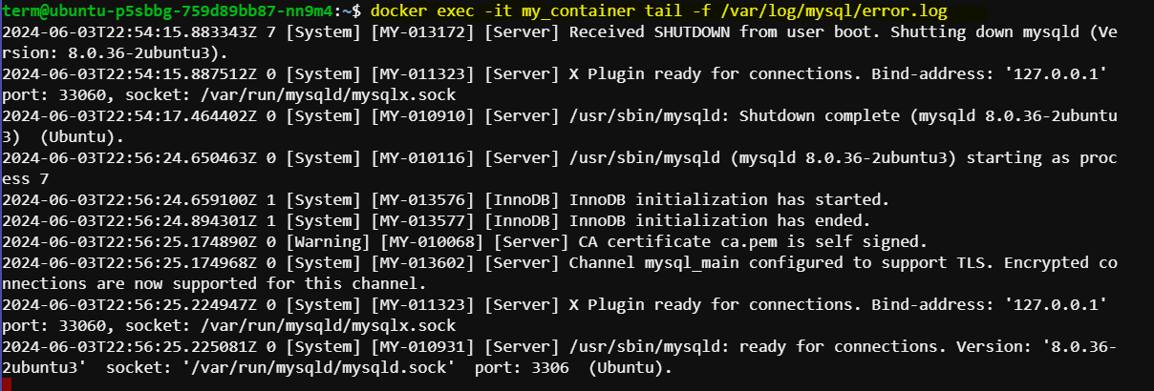

**Usage**

**Managing Services**

**Inside the running container, you can manage services using supervisorctl:**

# Check status of services

supervisorctl status

# Stop a service

supervisorctl stop nginx

# Start a service

supervisorctl start nginx

# Restart a service

supervisorctl restart nginx

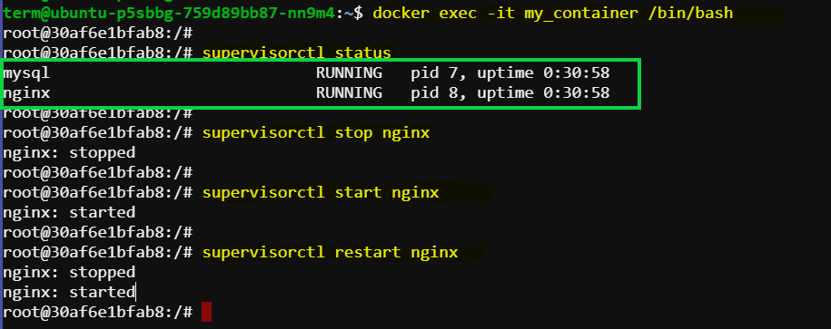

**Conclusion**

You now have a Docker container that simulates a traditional host environment capable of running multiple processes and services. You can extend this setup by adding more services or customizing configurations as per your requirements.